6th Grade Geography
Cause & Effect Paper
Due April 7th, 2015

Knowing the true causes of a problem can lead to people being able to better come up with a realistic and long-lasting solution. In the case of many countries in Africa, people have been facing problems in their society, government, health, environment and relationship with other countries. This impacts people today, and they are still looking for the best solution.

Your task:
Research a specific, current problem that is happening in your assigned African country today and three causes of this problem. Organize your research into a 5-paragraph essay explaining the problem, its three causes, and one possible practical solution that could be implemented. Then, present your research in a creative way to the class!

See p600 Textbook for tips and tricks!

Deadlines:

_____Country/Problem/3 Causes: Monday, March 9th
_____Bring 20 blank note cards to class!: Monday, March 9th
_____15 Research Note Cards Completed and Source Card (at least 5 sources): Monday, March 16th
_____Cause/Effect Essay Outline on turnitin.com: Monday, March 25th
_____Cause/Effect Essay Rough Draft on turnitin.com: Friday, March 27th
_____Cause/Effect Essay Final Draft on Turnitin.com: Tuesday, April 7th by 11:59pm
_____Cause/Effect Research Presentation: In class!: Sign up for a date April 8th-10th

1. Pick a country in Africa for your PPT presentation and your paper.

My country is: ____________________________________________

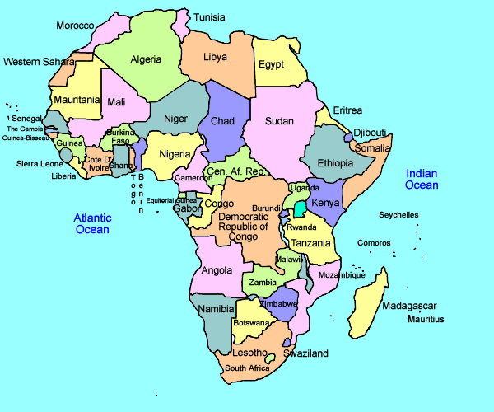
2. Research the country and find 1 specific problem that is happening in that country today. The problem could have to do with: Economy, Government/Politics, Social issues, Poverty, Healthcare, Climate and Agriculture, Environmental issues, Relationship with other countries, Religious or Cultural conflict. Use these websites to help you:
http://www.africaw.com/
http://www.our-africa.org/

A specific problem happening in this country is:

________________________________________________________________

________________________________________________________________

3. Research this problem:
Three main factors that cause most of the ___________________ problems in ___________________________today.

List the three causes of the problem here:
1.
2.
3.

4. Research 3-4 facts about each cause.
Write them on note cards and label your note cards. Keep these in your FOLDER.
-1 Source Note card: Lists websites or books you used to research (use reliable sources)
-15 Cause/Effect Note cards: Lists details about each of the three main causes of the problem in that country (Means 5 note card facts for each main cause)

5. Organize your research in an outline format (see attached)

6. Expand your outline into full paragraphs; careful to use your own words!
Explain the three causes of the main problem in this African country.

7. Rough draft of 5 paragraph Cause/Effect essay due on Turnitin.com on:

It will be considered late if you turn it in another way.

8. Read through my edits on your rough draft and make changes. Revise and edit your paper.

9. Submit Final Draft of Cause/Effect Paper to turnitin by 11:59pm on April 7th.
Come up with a creative way to present your research!
-Summarize the problem in this country
-The three causes of this problem
-A practical solution that the class could get involved in

Here are some website platforms you can use:
- http://www.powtoon.com/
- http://prezi.com/
- https://www.haikudeck.com/
- https://www.educreations.com/
- iMovie; must look professional/edited with music

Final Draft of Paper and Presentation due April 8-10th.

Sample Paper Process:

Brainstorm (getting ideas) through research:

Possible problems I could research in Zimbabwe include:
-Malaria
-HIV/AIDS
-Poor sanitation
-Lack of doctors
-Food shortages

Three causes of the Food Shortages:
1. Land Reform Program
2. Long-time Drought
3. Outside Influence

Research Cards:

Source Card:

1. http://www.our-africa.org/
2. http://www.africaw.com/major-problems-facing-zimbabwe-today
3. http://www.bbc.com/news/world-africa-14113249
4. http://www.irinnews.org/report/47337/zimbabwe-economic-crisis-compounds-food-shortages
5.

Land Reform Program: 1

- Zimbabwe grew a lot of tobacco and wheat: “breadbasket of Africa”
- Then: All white-owned farms taken over and given to native Zimbabweans
-Now: some people depend on the government for grain but a lot have left the country

Background Info: 1

Most people in Zimbabwe today are below the poverty line: make less than $1.25 a day.

4A Background Info 2
"What began as a food crisis in Zimbabwe in 2002 has grown into a major humanitarian emergency, with people suffering the effects of a deteriorating economy, HIV/AIDS, depleted social services and policy constraints," OCHA said in an appeal to donors.

Zimbabwe
Malaria and poor sanitation

